

**ASSIGNMENT # 1:**

**NAME**: Zainab Riaz

**ID:** F2023105129

**SECTION**: Y3

**COURSE**: Open Source Software

**SUBMITTED TO** : Ma’am Laila Zahra

**Problem 1:** Write a Python program to demonstrate basic data types (integer, float, string, Boolean, Complex). Print the values and their types.

**Code:**

# Integer

i = 42

print("Integer:", i, "Type:", type(i))

# Float

f = 3.14

print("Float:", f, "Type:", type(f))

# String

s = "Hello, Python!"

print("String:", s, "Type:", type(s))

# Boolean

b = True

print("Boolean:", b, "Type:", type(b))

# Complex number

c = 2 + 3j

print("Complex:", c, "Type:", type(c))

**Output:**

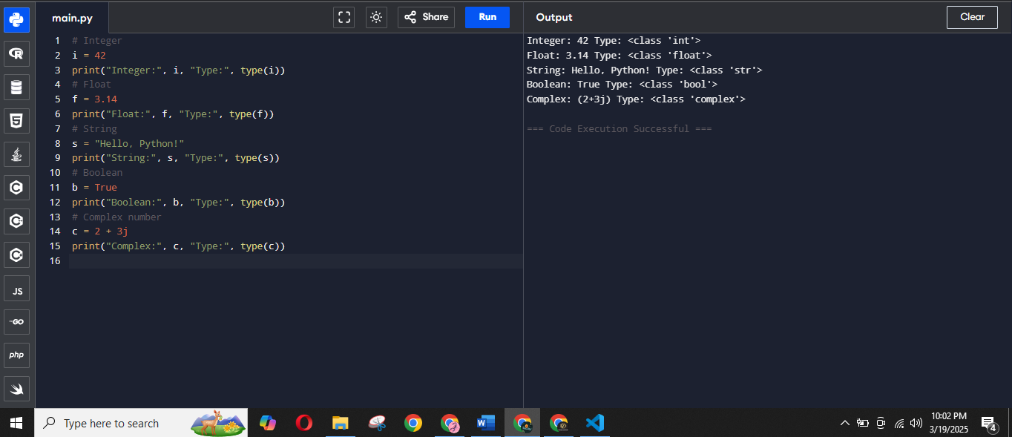

**Problem 2:** Create a list of your favorite colors. Perform the following operations:   
1. Print the first color.   
2. Print the last color.   
3. Add a new color to the list.

**Code:**

favorite_colors = ["Lilac", "Torquise", "Brown", "Purple", "Mint Green"]

print("First color:", favorite_colors[0])

print("Last color:", favorite_colors[-1])

favorite_colors.append("Neon")

print("Updated list of colors:", favorite_colors)

**Output**

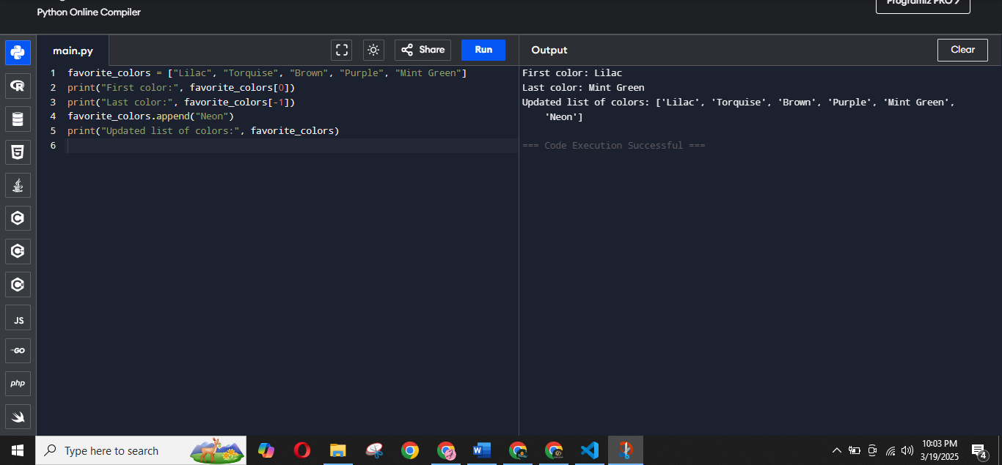

**Problem 3:** Create a set of unique numbers. Perform the following operations:   
1. Add a new number to the set.   
2. Remove a number from the set.   
3. Print the set.

**Code**

unique_numbers = {19, 28, 36, 45, 54}

unique_numbers.add(69)

unique_numbers.remove(36)

print("Updated set:", unique_numbers)

**Output**

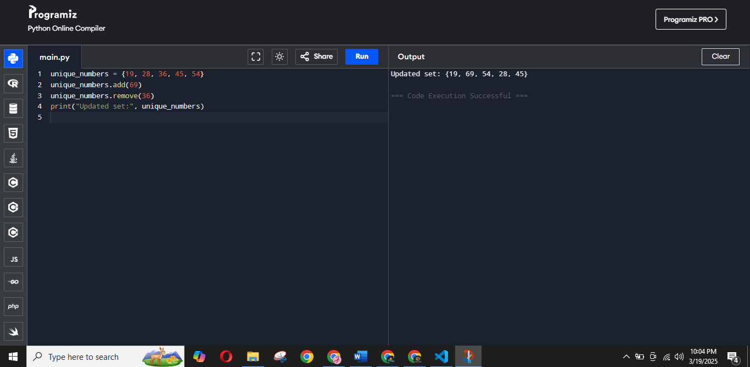

**Problem 4:** Create a tuple of your favorite fruits. Perform the following operations:  
 1. Print the second fruit.   
2. Try to change the first fruit (observe the error).   
3. Print the length of the tuple.

**Code**

favorite_fruits = ("Kiwi", "Banana", "Cherry", "Mango")

print("Second fruit:", favorite_fruits[1])

try:

favorite_fruits[0] = "Starfruit" #ERROR OBSERVED

except TypeError as e:

print("Error:", e)

print("Length of the tuple:", len(favorite_fruits))

**Output**

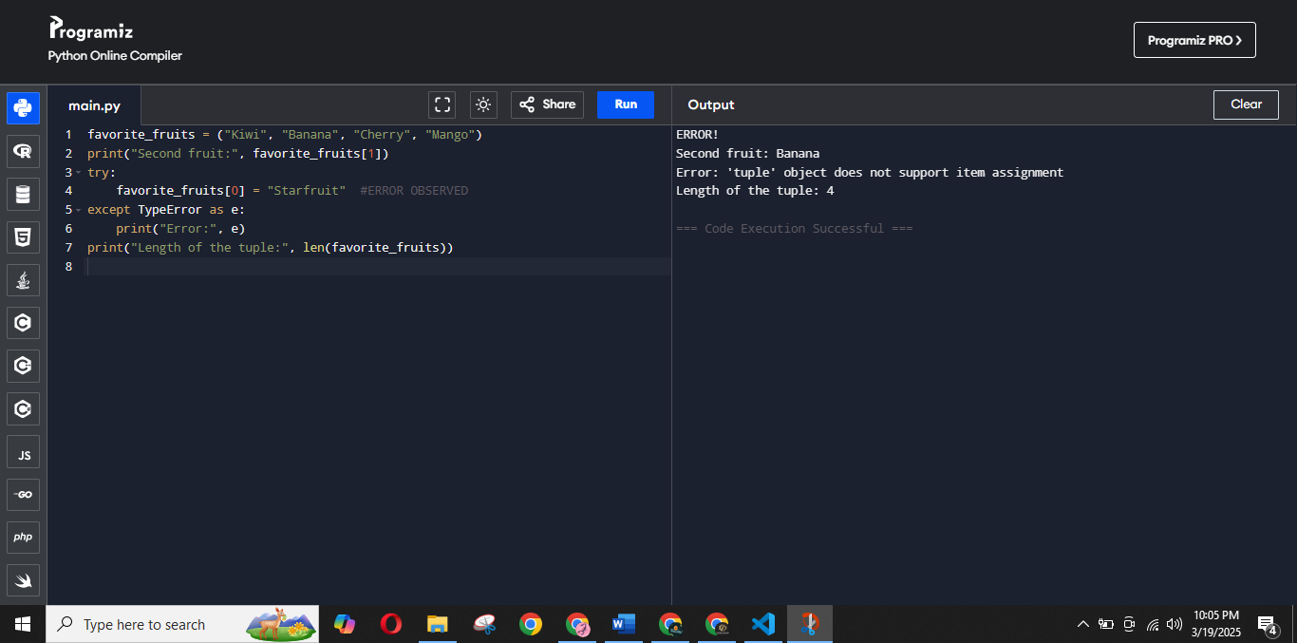

**Problem 5:** Create a dictionary to store student names and their corresponding ages. Perform the following operations:   
1. Print the age of a specific student.   
2. Add a new student to the dictionary.   
3. Print the dictionary.

**Code**

students_ages = {

"Nighat": 18,

"Shameem": 19,

"Abdul Wadood": 20,

}

student_name = "Abdul Wadood"

print(f"Age of {student_name}:", students_ages.get(student_name, "Student not found"))

students_ages["Noor e Azal"] = 21

print("Updated dictionary:", students_ages)

**Output**

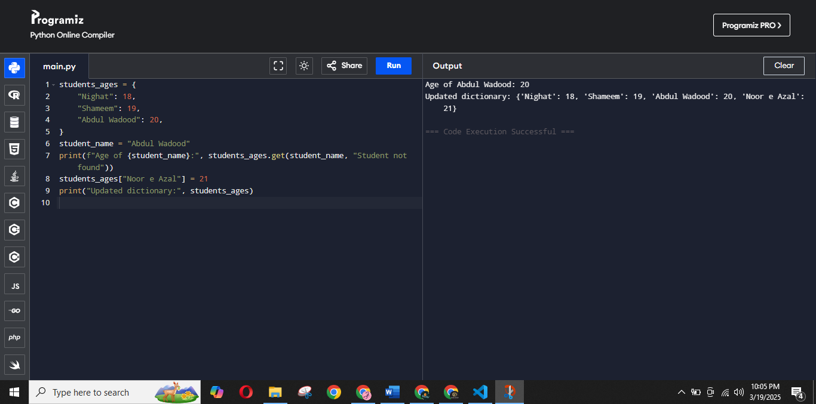

**Problem 6:** Create a set of even numbers. Check if a specific number is present in the set.

**Code**

even_numbers = {2, 4, 6, 8, 10, 12, 14, 16, 18}

specific_number = 10

if specific_number in even_numbers:

print(f"{specific_number} is present in the set.")

else:

print(f"{specific_number} is not present in the set.")

**Output**

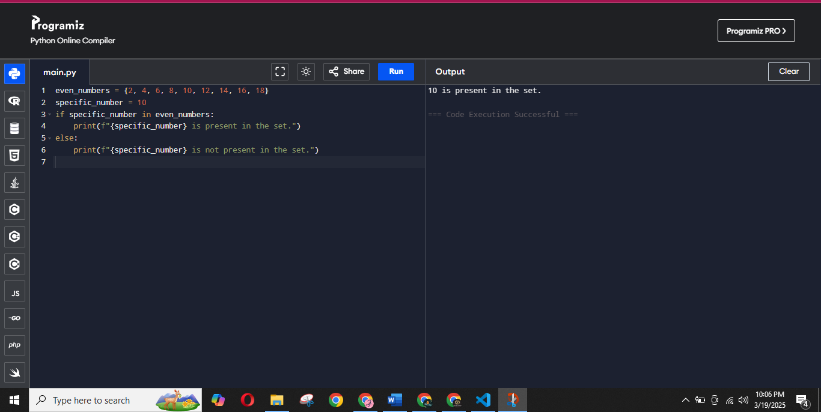

**Problem 7:** Create a dictionary of items and their prices. Access and print the price of a specific item.

**Code**

items_prices = {

"Kiwi": 150,

"Banana": 100,

"Cherry": 200,

"Mango": 350

}

item_name = "Banana"

print(f"The price of {item_name} is: ${items_prices.get(item_name, 'Item not found')}")

**Output**

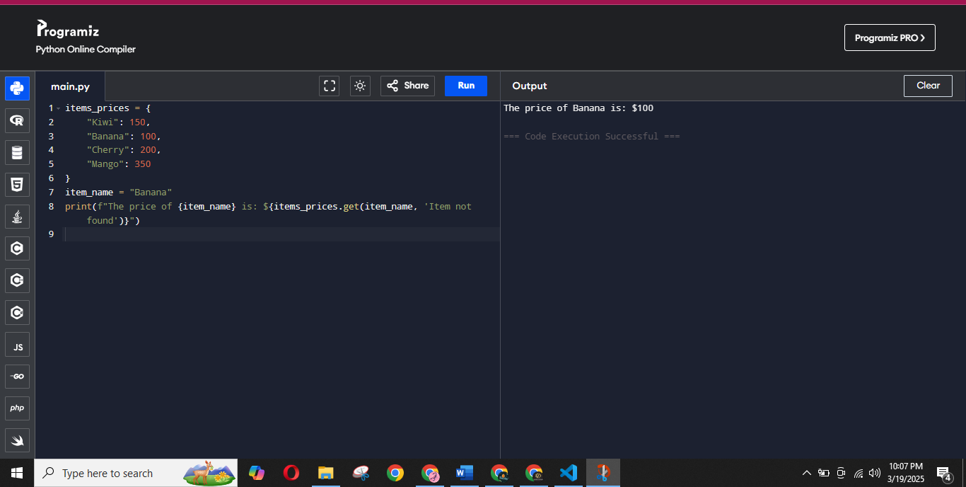

**Problem 8**: Write a Python program to create a multi-line string that contains your introduction. Your introduction should include the following details: Your name, your age, your city, your hobbies, your favorite subject, your favorite food, your favorite programming language or book, your dream job, A fun fact about yourself, A closing statement.

**Code**

introduction = """

Konichiwa! My name is Zainab Riaz.

I am 19 years old, and I live in Lahore.

My favourite hobby is reading.

My favorite subject depends on the teacher, and my favorite dish is Poulet Marrakesh.

My favourite book is Usri Yusra right now.

My dream job is to work at google.

A fun fact about me is that I can overthink at any extent.

I look forward to learning and growing in the life.

"""

# Print the multi-line string

print(introduction)

**Output**

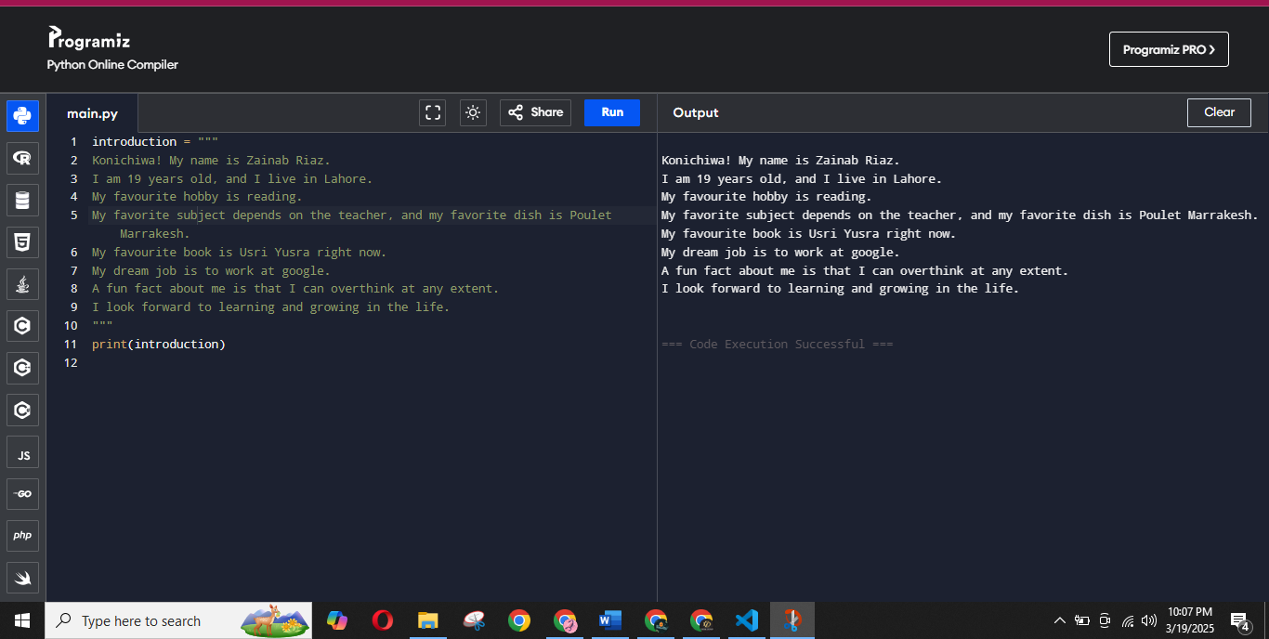

**THE END**